Multi-system voting machine
The basic idea behind ​​this project is to build an electronic voting machine with multiple systems (Plurality, Majority & Borda count).
Este documento foi desenvolvido por Andrei Inoue Hirata está protegido por direitos autorais, sendo vedada sua reprodução sem autorização prévia do autor.

Devices & Components
- 1 Arduino Mega 2560 Rev3
- 1 Buzzer
- 5 push button
- 1 5 mm LED: Red
- 1 Jumper wires (generic)
- 1 Rotary potentiometer (generic)
- 1 Alphanumeric LCD, 20 x 4
- 1 Breadboard (generic)
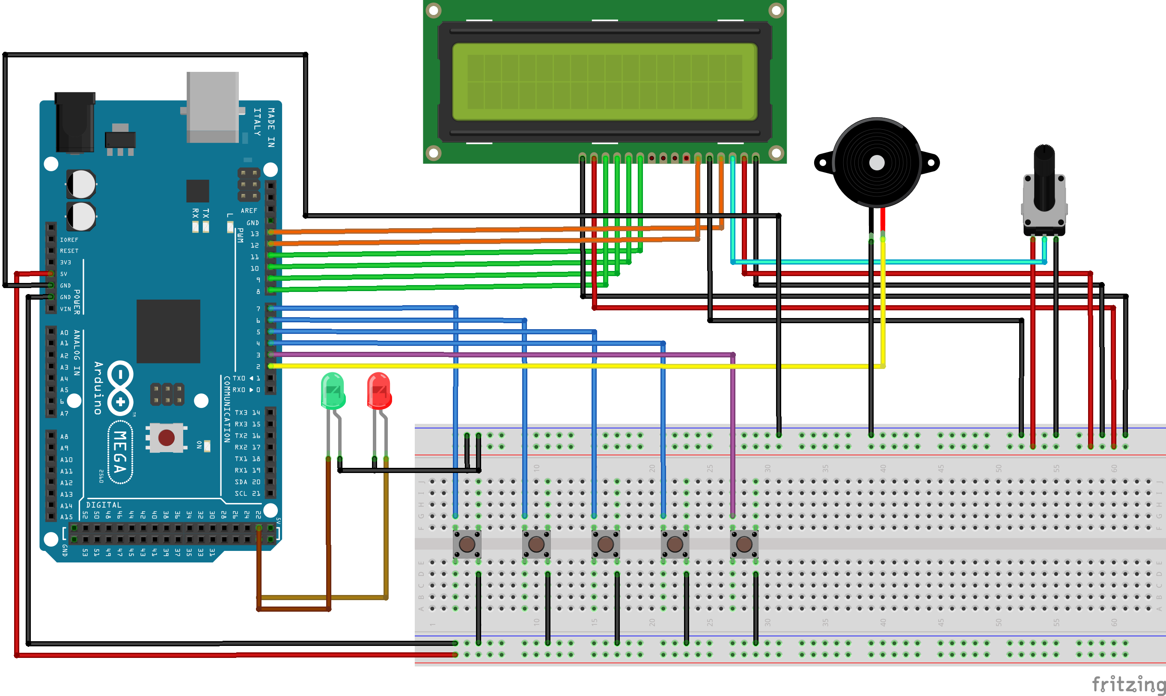
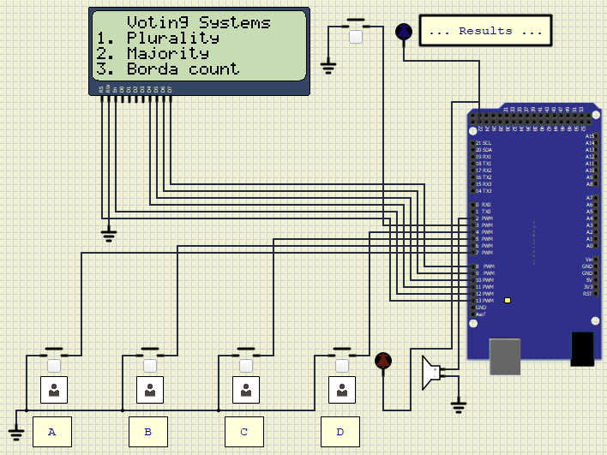

Project description
The idea behind this project is to build an electronic voting machine with multiple systems (plurality, majority, and Borda). I will add more later.
This machine can show multiple results such as total votes, vote percentage, equal votes, majority percentage, ranking & points for the Borda count method.
For this electronic voting machine project, we have used four push buttons for four different candidates taking part in the election.
However, you can increase the number of candidates as per your requirements. Actually, when a voter presses any four buttons, the value of the vote will increase each time. After completing the entire voting process, the result button can be pressed to display the result on an LCD screen & Serial monitor.
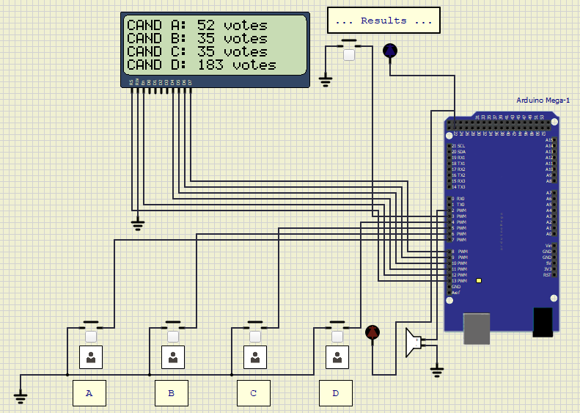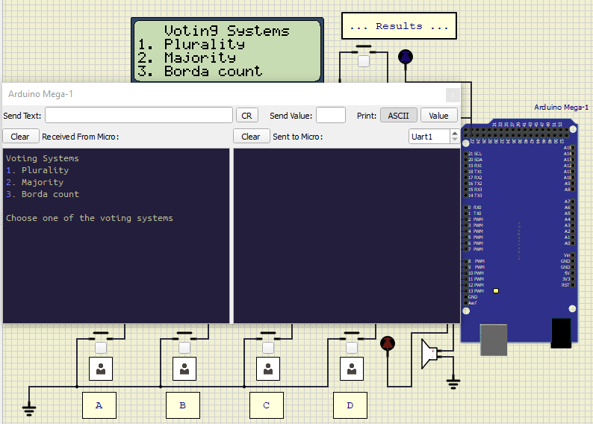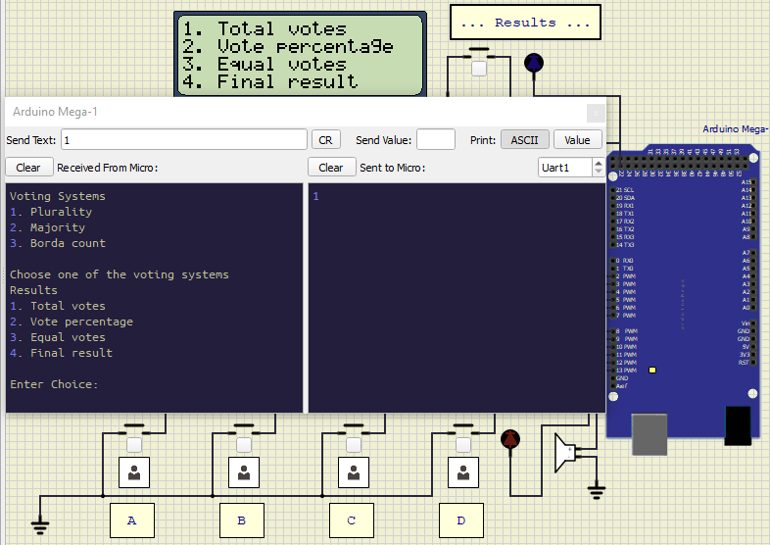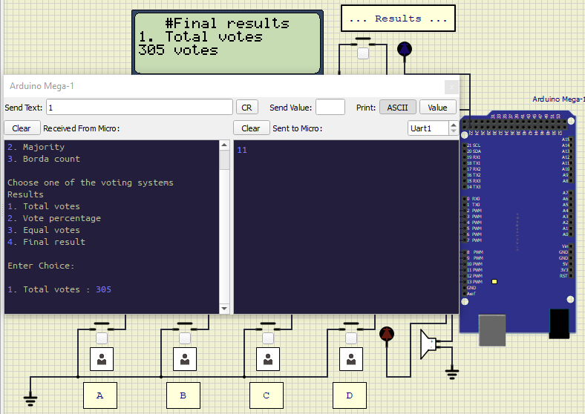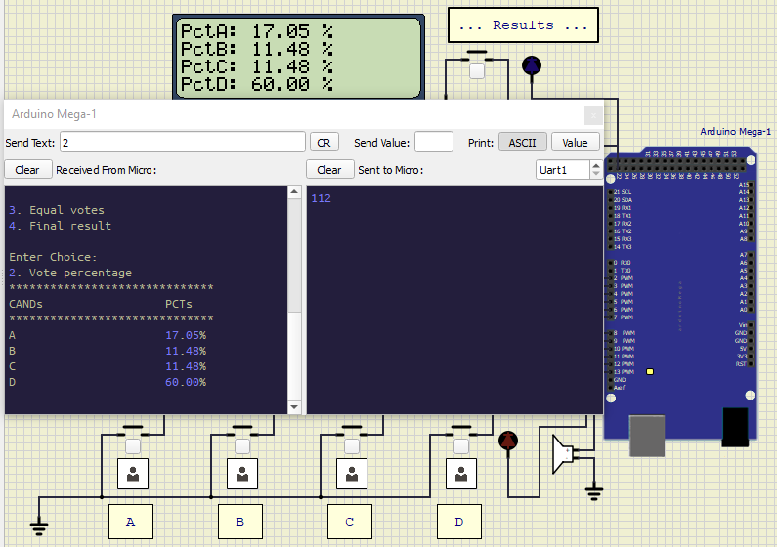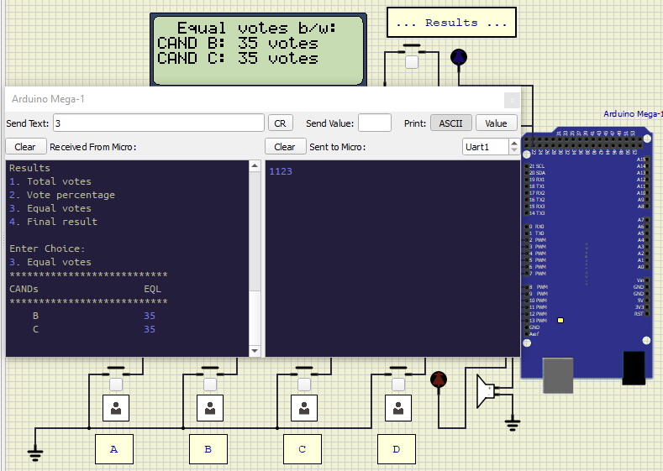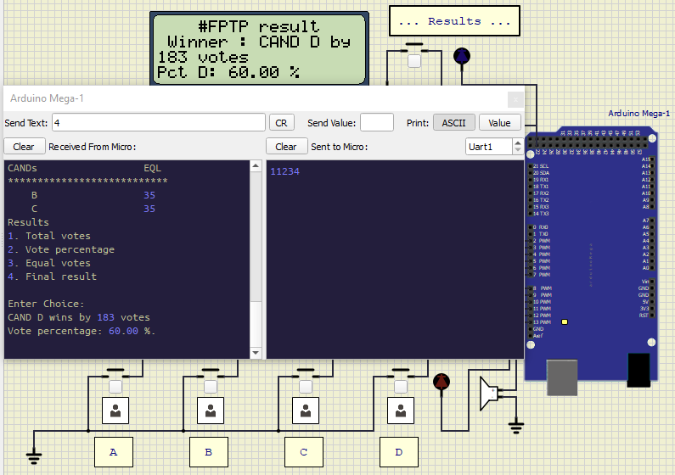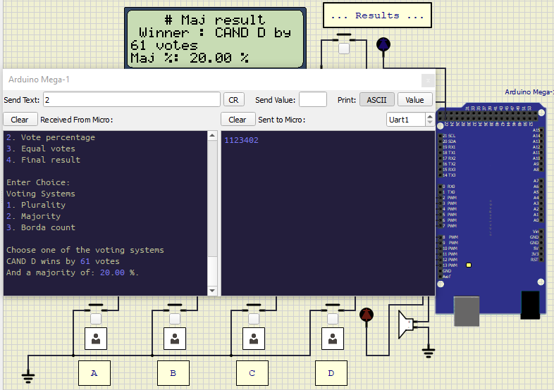
3. Borda count method :
When choosing the Borda count method, you have to first insert the rankings.
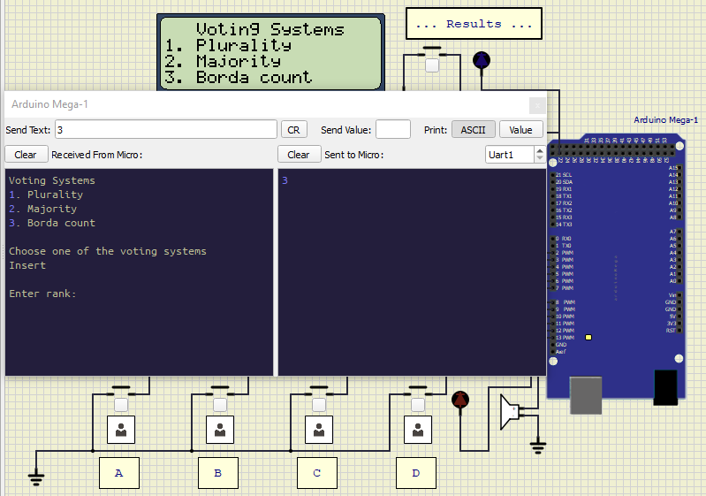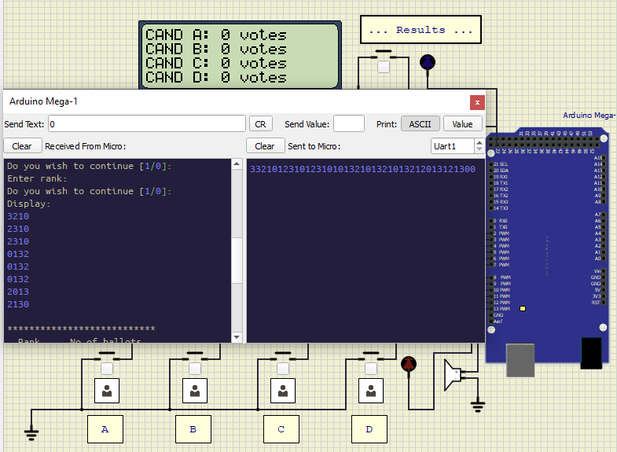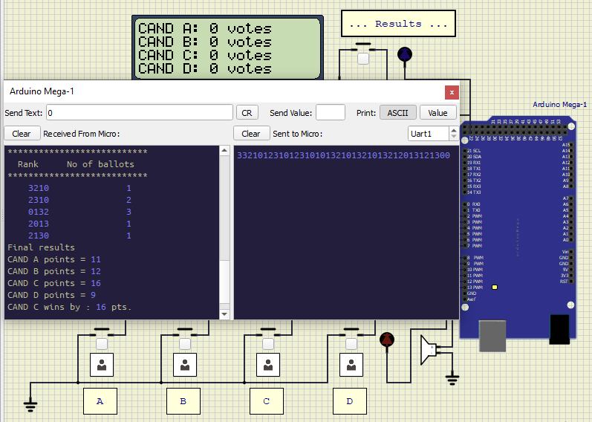

Code

#include<LiquidCrystal.h>
LiquidCrystal lcd(13, 12, 11, 10, 9, 8);

#define S1 7
#define S2 6
#define S3 5
#define S4 4
int vote1=0;
int vote2=0;
int vote3=0;
void setup()
{
pinMode(S1, INPUT);
pinMode(S2,INPUT);
pinMode(S3,INPUT);
pinMode(S4,INPUT);
pinMode(LED_BUILTIN, OUTPUT);

lcd.begin(16, 2);
lcd.print(" Electronic ");
lcd.setCursor(0,1);
lcd.print(" Voting Machine ");
delay(4000);
lcd.clear();
delay(1000);
lcd.print(" PBL Made by : ");
lcd.setCursor(0,1);
lcd.print(" Shlok 47 ,");
delay(2000);
lcd.setCursor(0,1);
lcd.print(" Ayush 58 ,");
delay(2000);
lcd.setCursor(0,1);
lcd.print(" Monish 62 .");
delay(2000);
lcd.clear();
delay(1000);
digitalWrite(S1, HIGH);
digitalWrite(S2, HIGH);
digitalWrite(S3, HIGH);
digitalWrite(S4, HIGH);
lcd.clear();
lcd.setCursor(1,0);
lcd.print("%");
lcd.setCursor(6,0);
lcd.print("#");
lcd.setCursor(12,0);
lcd.print("$");
}
void loop()
{
lcd.setCursor(1,0);
lcd.print("%");
lcd.setCursor(1,1);
lcd.print("IT");
lcd.setCursor(6,0);
lcd.print("#");
lcd.setCursor(6,1);
lcd.print("CSE");
lcd.setCursor(12,0);
lcd.print("$");
lcd.setCursor(12,1);
lcd.print("ECE");
if(digitalRead(S1)==0)
{
digitalWrite(LED_BUILTIN, HIGH);

vote1++;
while(digitalRead(S1)==0);
digitalWrite(LED_BUILTIN, LOW);
delay(500);
}
if(digitalRead(S2)==0)
{
digitalWrite(LED_BUILTIN, HIGH);
vote2++;
while(digitalRead(S2)==0);
digitalWrite(LED_BUILTIN, LOW);
delay(500);
}
if(digitalRead(S3)==0)
{
digitalWrite(LED_BUILTIN, HIGH);
vote3++;
while(digitalRead(S3)==0);
digitalWrite(LED_BUILTIN, LOW);
delay(500);
}
if(digitalRead(S4)==0)
{
digitalWrite(LED_BUILTIN, HIGH);
digitalWrite(LED_BUILTIN, LOW);
delay(500);
int vote=vote1+vote2+vote3;
if(vote)
{
if((vote1 > vote2 && vote1 > vote3))
{
lcd.clear();
lcd.print(" IT is Winner!! ");
delay(3000);
lcd.clear();
lcd.setCursor(1,0);
lcd.print("IT");
lcd.setCursor(1,1);
lcd.print(vote1);
lcd.setCursor(6,0);
lcd.print("CSE");
lcd.setCursor(6,1);
lcd.print(vote2);
lcd.setCursor(12,0);
lcd.print("ECE");
lcd.setCursor(12,1);
lcd.print(vote3);
delay(2000);
lcd.clear();
//exit(0);
}
else if((vote2 > vote1 && vote2 > vote3))
{
lcd.clear();
lcd.print(" CS is Winner!! ");
delay(3000);
lcd.clear();
lcd.setCursor(1,0);
lcd.print("IT");
lcd.setCursor(1,1);
lcd.print(vote1);
lcd.setCursor(6,0);
lcd.print("CSE");
lcd.setCursor(6,1);
lcd.print(vote2);
lcd.setCursor(12,0);
lcd.print("ECE");
lcd.setCursor(12,1);
lcd.print(vote3);
delay(2000);
lcd.clear();
//exit(0);
}
else if((vote3 > vote1 && vote3 > vote2))
{
lcd.clear();
lcd.print("ECE is Winner!! ");
delay(3000);
lcd.clear();
lcd.setCursor(1,0);
lcd.print("IT");
lcd.setCursor(1,1);
lcd.print(vote1);
lcd.setCursor(6,0);
lcd.print("CSE");
lcd.setCursor(6,1);
lcd.print(vote2);
lcd.setCursor(12,0);
lcd.print("ECE");
lcd.setCursor(12,1);
lcd.print(vote3);
delay(2000);
lcd.clear();
//exit(0);

}
else
{
lcd.clear();
lcd.print(" Tie Up Or ");
lcd.setCursor(0,1);
lcd.print(" No Result ");
delay(3000);
lcd.clear();
lcd.setCursor(1,0);
lcd.print("IT");
lcd.setCursor(1,1);
lcd.print(vote1);
lcd.setCursor(6,0);
lcd.print("CSE");
lcd.setCursor(6,1);
lcd.print(vote2);
lcd.setCursor(12,0);
lcd.print("ECE");
lcd.setCursor(12,1);
lcd.print(vote3);
delay(2000);
//exit(0);
}

}
else
{
lcd.clear();
lcd.print("No Voting done!");
delay(3000);
lcd.clear();
//exit(0);
}
vote1=0;vote2=0;vote3=0,vote=0;
lcd.clear();
}
}

https://projecthub.arduino.cc/yah_ham/multi-system-voting-machine-5ae6e7#section0

